**Reports Generator**

**Final Report**

**Ben McEwen, Vicente Ramos, Dalton Petsch, David Van Dewerker**

**4/8/2020**

**1. Project Summary**

For our project, we are creating a Marketing Effects Report Generator(MERG). This marketing report generator will be a web application that pulls data from various online tools, the data is then consolidated and displayed on a web page. The application is used by the account managers of White Stone Marketing, who is a digital marketing agency. They will be using it to create marketing reports for their clients. The overall purpose of the report would be to convey the results of the current marketing strategy and to facilitate the elicitation of future strategies. The report is presented via a secure website, during scheduled meetings, as most participants are remotely located.

The database and website will be hosted on the Bluehost server. Records will be added, updated, and fetched from the database via the website. The website will send requests to and receive information from various APIs. The data received from the API will be used to create graphs and charts. The system will generate new web pages to display the graphs and charts so they can be viewed by the users. There are three types of users, Senior Account Managers, Account Managers, and Inn Owners. The Inn Owners are the clients of White Stone Marketing, they own high-end boutique Bed and Breakfast style inns. The inn owners should only be able to view the marketing reports.  The Account Managers are employees of White Stone Marketing, they interact directly with the Inn Owners to discuss marketing strategies and budget. Account Managers should be able to generate and view marketing reports. The Senior Account Manager supervises and mentors the Account Managers as well as provides higher-end services such as data analysis and elicitation of effective marketing strategies to the Inn Owners. The Senior Account Manager should be able to generate and view marketing reports as well as edit the profiles of the Account Managers and Inn Owners

**2. Overall Status  - Complete**

**Functional Requirements**

User Requirements

Senior Account Managers

1.   The Senior Managers must be able to edit Account Managers' profiles.

2.   The Senior Managers must be able to edit Inn Owners’ profiles.

3.   Account Managers must be able to login to the Marketing Report Generator page.

4.   Account Managers must be able to generate the reports.

4.1   Senior Account Managers must be able to specify which Inn Owner the report is generated for.

4.2   Senior Account Managers must be able to specify the date range the report is generated for.

4.3   Senior Account Managers must be able to specify any combination of sources the report is generated from.

4.4   Possible Sources: Google Analytics, MailChimp, Facebook, Cart Stack, Trip Tease, Think Reservations. Specific details regarding which sources to be provided by White Stone Marketing after 11/4/2019.

Account Managers

5.   Account Managers must be able to login to the Marketing Report Generator page.

6.   Account Managers must be able to generate the reports.

6.1   Account Managers must be able to specify which Inn Owner the report is generated for.

6.2   Account Managers must be able to specify the date range the report is generated for.

6.3   Account Managers must be able to specify any combination of sources the report is generated from.

6.4   Possible Sources: Google Analytics, MailChimp, Facebook, Cart Stack, Trip Tease, Think Reservations. Specific details regarding which sources to be provided by White Stone Marketing after 11/4/2019.

7.   Account managers must be able to access everything the Inn Owners can access.

Inn Owners

8.   Inn Owners must be able to login to view the report page.

9.   Inn Owners must NOT be able to view other Inn Owners’ report page.

10.   Inn Owners must be able to view all previously generated reports.

**System Requirements**

Assumptions

1.   The database has been created.

2.   Profile information for each Senior Account Manager has been added to the database.

3.   The user has navigated to the website which hosts the MERG web application.

General System Requirements

Web Pages

1.   The system should have the following pages.

1.1   Senior Account Manager’s page.

1.1.1          Accessible to Senior Account Managers only.

1.2   Account Manager’s page.

1.2.1          Accessible to Account Managers and Senior Account Managers

1.3   Inn Owner’s pages.

1.3.1           Accessible to Inn Owners, Account Managers, and Senior Account Managers.

1.3.2          Each Inn Owner’s page should not be accessible to other Inn Owners.

1.3.3          Each Inn Owner should have a page with a unique URL. (ex. *www.merg.com/clientId/index.html)*

1.4   Marketing report pages.

1.4.1          Accessible to pertinent Inn Owners, Account Managers, and Senior Account Managers.

1.4.1.1 Each marketing report page should have a unique URL. (ex. *www.merg.com clientId/mm_dd_yyy.html*)

Marketing Report

2.   The system should generate marketing reports based upon metrics specified by either the Account Manager or Senior Account manager.

2.1   The system should request data from sources.

2.2   The system should generate a new file for each report generated.

2.3   The system should store the file path (URL) for each marketing report.

2.4   The system should write data received from sources to the file.

User Interactions

User Authentication

3.   The system must authenticate each user.

3.1   The System should gather a username and password.

3.2   System should compare credentials provided by the user to those stored in the database.

3.3   The System should retrieve user types from the database.

3.4   System should redirect to the user page based on user type.

Senior Account Managers (SAM) Interactions

4.   The system must authenticate SAM

5.   The system should redirect SAM to the Senior Account Manager’s page.

6.   The system should allow SAM to edit user profiles.

7.   The system should allow SAM to display all account managers.

8.   The system should allow SAM to display all Inn owners.

9.   The system should allow SAM to specify metrics for marketing reports.

9.1       The system should allow SAM to specify which Inn Owner to generate a report for.

9.2       The system should allow SAM to specify a Start date for the report.

9.3       The system should allow SAM to specify an End date for the report.

9.4       The system should allow SAM to specify sources for the report.

10.   The system should allow SAM to indicate they would like the report to be generated.

Account Managers (AM) Interactions

11.   The system must authenticate AM.

12.   The system should redirect AM to the Account Manager’s page.

13.   The system should allow AM to edit user profiles.

14.   The system should allow AM to display all account managers.

15.   The system should allow AM to display all Inn owners.

16.   The system should allow AM to specify metrics for marketing reports.

16.1           The system should allow AM to specify which Inn Owner to generate a report for.

16.2           The system should allow AM to specify a Start date for the report.

16.3           The system should allow AM to specify an End date for the report.

16.4           The system should allow AM to specify sources for the report.

17.   The system should allow AM to indicate they would like the report to be generated.

Inn Owners (IO) Interactions:

18.   The system must authenticate IO.

19.   The system should redirect IO to the Inn Owner’s page.

20.   The system should request the URLs for the marketing reports from the database.

21.   The system should display URLs with labels so that IO can identify the marketing report. (ex. Report for 10/1/2019 to 11/1/2019)

22.   The system should allow IO to select a URL.

23.   The system should redirect to the specified URL.

Non-Functional Requirements

1.   The system shall be accessible from the following browsers: Chrome, Firefox, Safari, and Edge.

2.   The System shall always be accessible by all users.

3.   Passwords shall never be viewable at any point. (ex. Password box shows ********* rather than actual characters)

4.   A video should be provided demonstrating the functionality of AM related features.

5.   Usability

5.1. The system must be faster and easier to use than the existing system.

5.2. Faster: White Stone’s existing system takes roughly 45 min. MERG should allow SAM and AMs to generate the marketing reports in less than 5 min from the time they are authenticated to the time the report is generated. This is an arbitrary number provided by White Stone Marketing, longer times may be acceptable if necessary.

5.3. Easier: The current system requires SAM and AM to have a working knowledge of how to navigate the websites for each of the sources, screen capturing, image manipulation, and WordPress. MERG should allow the reports to be generated by SAM and AM after watching the demo video once.

5.4. Usability tests will be designed and conducted by White Stone Marketing on both the existing system and MERG.

**3. Team Member Roles**

**Ben McEwen** – Ben is our team leader. He had the idea of the reports generator when he saw a need for a local marketing company. He is also our expert developer and wrote the majority of the code and made sure all other code was implemented correctly. Ben also stayed in contact with Dr. Mostowfi as well as White Stone Marketing to provide progress updates while requesting feedback. Overall, Ben was the heart and soul of our team.

**Vicente Ramos** – Vicente was another one of our team members who wrote code and got our web pages all set up and working correctly. He also helped with doing the use cases regarding the web pages during the first semester. Vicente worked hard to ensure that we could add, edit, and delete entries on our web pages with PHP code to make changes in our database. He was in charge of all of the PHP code changes and implementation and did a great job getting it all working correctly with our database.

**Dalton Petsch** – Dalton oversaw the documentation and writing, as well as parts of the database creation and implementation. He worked on use cases, data flow diagrams, the ERD for the database, and the implementation of exporting our database into our Bluehost account. He also worked on this final report.

**David Van Dewerker** – David also worked on the database as well as some of the documentation from the first semester. He worked hard on creating and implementing our database and making sure it worked fine. He worked on aspects like implementing the foreign keys and making sure that all relations and constraints worked fine. He worked alongside Vicente in writing some of the necessary PHP code.

**4. Status by requirement**

**Status of Functional Requirements**

Senior Account Managers

1.   The Senior Managers must be able to edit Account Managers' profiles.

Status: completed, UC-5 see figure 5. Functionality is shown in the linked video

2.   The Senior Managers must be able to edit Inn Owners’ profiles.

Status: completed, UC-5 see figure 5. Functionality is shown in the linked video

3.   Account Managers must be able to login to the Marketing Report Generator page.

Status: completed, UC-1 see figure 1. Functionality is shown in the linked video

4.   Account Managers must be able to generate the reports.

4.1   Senior Account Managers must be able to specify which Inn Owner the report is generated for.

4.2   Senior Account Managers must be able to specify the date range the report is generated for. This requirement has been omitted as only past 30 days required

4.3   Senior Account Managers must be able to specify any combination of sources the report is generated from.

4.4   Possible Sources: Google Analytics, MailChimp, Facebook, Cart Stack, Trip Tease, Think Reservations.

Status: completed, UC-2 see figure 2. Functionality is shown in Merg-demo Video

Account Managers

5.   Account Managers must be able to login to the Marketing Report Generator page.

Status: completed, UC-1 see figure 1. Functionality is shown in the linked video

6.   Account Managers must be able to generate the reports.

6.1   Account Managers must be able to specify which Inn Owner the report is generated for.

6.2   Account Managers must be able to specify the date range the report is generated for. This requirement has been omitted as only past 30 days required

6.3   Account Managers must be able to specify any combination of sources the report is generated from.

6.4   Possible Sources: Google Analytics, MailChimp, Facebook, Cart Stack, Trip Tease, Think Reservations.

Status: completed, UC-2 see figure 2. Functionality is shown in Merg-demo Video

7.   Account managers must be able to access everything the Inn Owners can access.

Status: completed, UC-2 see figure 2. Functionality is shown in Merg-demo Video

Inn Owners

8.   Inn Owners must be able to login to view the report page.

Status: completed, UC-1 see figure 1. Functionality is shown in the linked video

9.   Inn Owners must NOT be able to view other Inn Owners’ report page.

Status: completed, UC-7 see figure 7. Functionality is shown in the Merg-demo video

10.   Inn Owners must be able to view all previously generated reports.

Note: this requirement has been changed at the client's request. The Inn Owners page is now a dynamic real-time dashboard displaying stats for the past 30days.

Status: completed, UC-7 see figures 7-10. Functionality is shown in the Merg-demo video

**System Requirements**

Assumptions

1. The database has been created.

See ERD in figure 11, Functionality shown in the linked video.

2.   Profile information for each Senior Account Manager has been added to the database.

3.   The user has navigated to the website which hosts the MERG web application.

User Interactions

User Authentication

3.   The system must authenticate each user. - complete

3.1   The System should gather a username and password. - complete

3.2   System should compare credentials provided by the user to those stored in the database. - complete

3.3   The System should retrieve user types from the database. - complete

3.4   System should redirect to the user page based on user type. - complete

Senior Account Managers (SAM) Interactions

4.   The system must authenticate SAM – complete - modified

5.   The system should redirect SAM to the Senior Account Manager’s page. - complete

6.   The system should allow SAM to edit user profiles. - complete

7.   The system should allow SAM to display all account managers. - complete

8.   The system should allow SAM to display all Inn owners. - complete

9.   The system should allow SAM to specify metrics for marketing reports. -removed by client

9.1       The system should allow SAM to specify which Inn Owner to generate a report for. - complete

9.2       The system should allow SAM to specify a Start date for the report. – removed by client

9.3       The system should allow SAM to specify an End date for the report. – removed by client

9.4       The system should allow SAM to specify sources for the report. – removed by client

10.   The system should allow SAM to indicate they would like the report to be generated. - complete

Account Managers (AM) Interactions

11.   The system must authenticate AM. - complete

12.   The system should redirect AM to Account Manager’s page. - complete

13.   The system should allow AM to edit user profiles. - complete

14.   The system should allow AM to display all account managers. - complete

15.   The system should allow AM to display all Inn owners. – complete modified

16.   The system should allow AM to specify metrics for marketing reports. – removed by client

16.1           The system should allow AM to specify which Inn Owner to generate a report for. - complete

16.2           The system should allow AM to specify a Start date for the report. – removed by client

16.3           The system should allow AM to specify an End date for the report. – removed by client

16.4           The system should allow AM to specify sources for the report. – removed by client

17.   The system should allow AM to indicate they would like the report to be generated. - complete

Inn Owners (IO) Interactions:

18.   The system must authenticate IO. - complete

19.   The system should redirect IO to the Inn Owner’s page. – complete modified

20.   The system should request the URLs for the marketing reports from the database. – removed by client

21.   The system should display URLs with labels so that IO can identify the marketing report. (ex. Report for 10/1/2019 to 11/1/2019) – removed by client

22.   The system should allow IO to select a URL. – removed by client

23.   The system should redirect to the specified URL. - complete

Non-Functional Requirements

1.   The system shall be accessible from the following browsers: Chrome, Firefox, Safari, and Edge. - complete

2.   The System shall always be accessible by all users. – removed by client

3.   Passwords shall never be viewable at any point. (ex. Password box shows ********* rather than actual characters) – completed see figure12

4.   A video should be provided demonstrating the functionality of AM related features. - completed

5.   Usability - To be tested by the client

5.1. The system must be faster and easier to use than the existing system.

5.2. Faster: White Stone’s existing system takes roughly 45 min. MERG should allow SAM and AMs to generate the marketing reports in less than 5 min from the time they are authenticated to the time the report is generated. This is an arbitrary number provided by White Stone Marketing, longer times may be acceptable if necessary.

5.3. Easier: The current system requires SAM and AM to have a working knowledge of how to navigate the websites for each of the sources, screen capturing, image manipulation, and WordPress. MERG should allow the reports to be generated by SAM and AM after watching the demo video once.

5.4. Usability tests will be designed and conducted by White Stone Marketing on both the existing system and MERG.

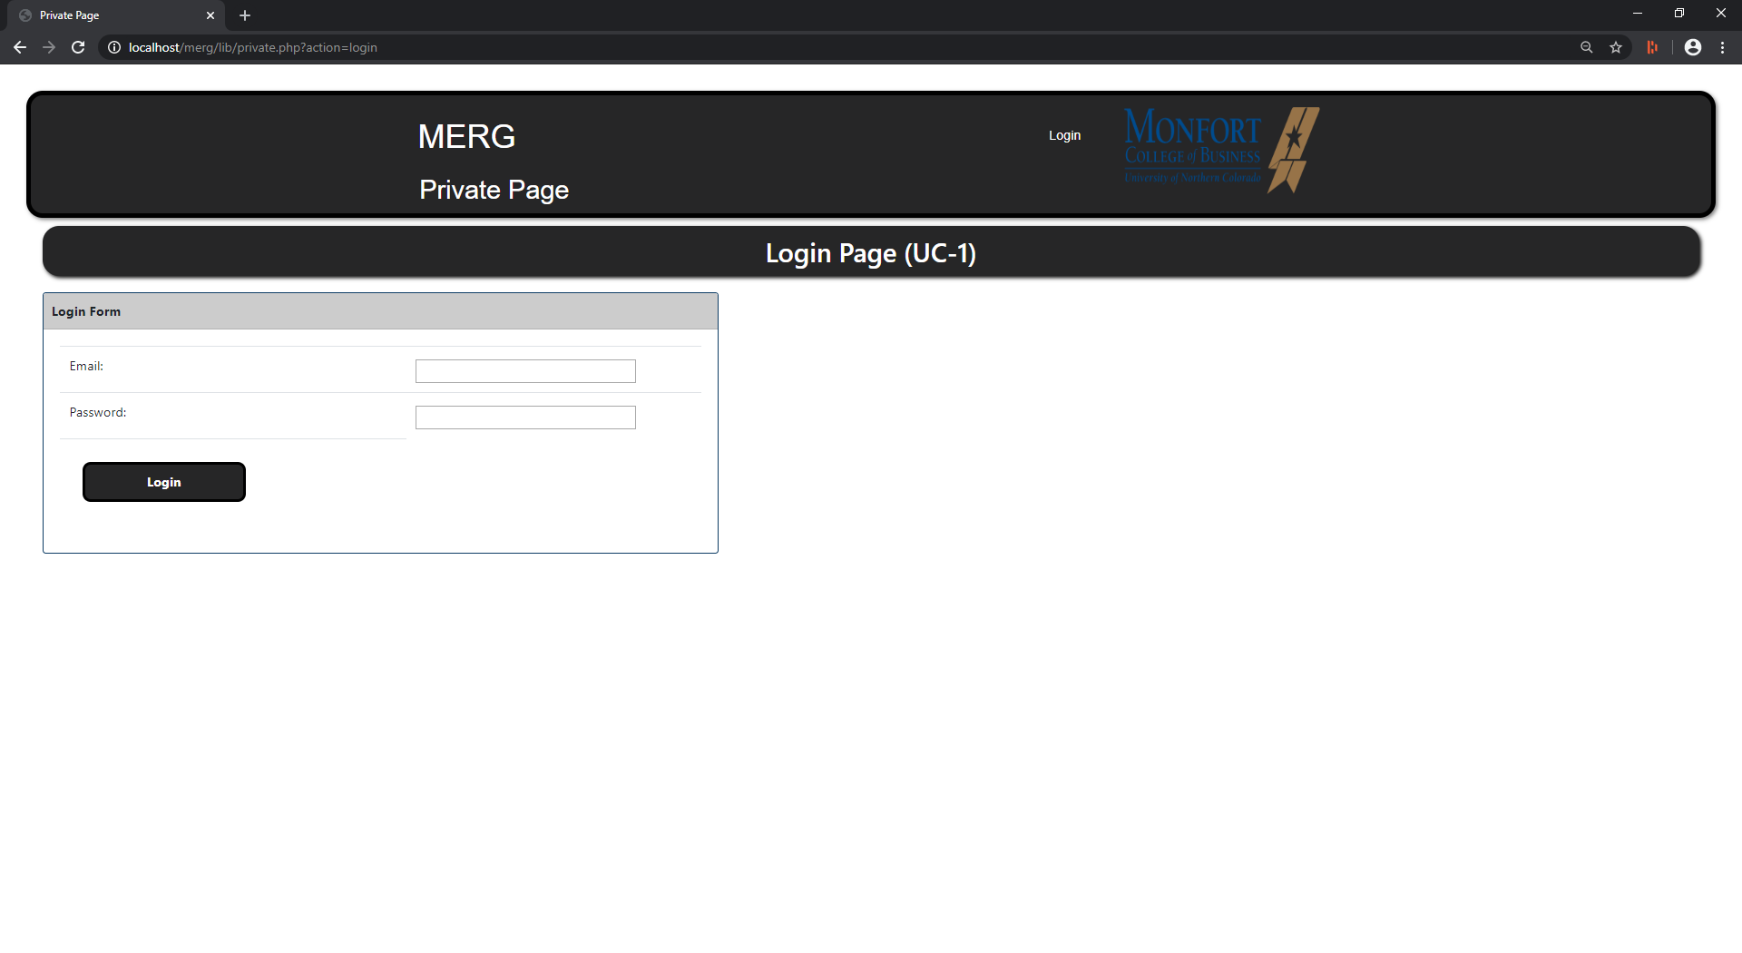

Figure 1. UC-1 Login Screen

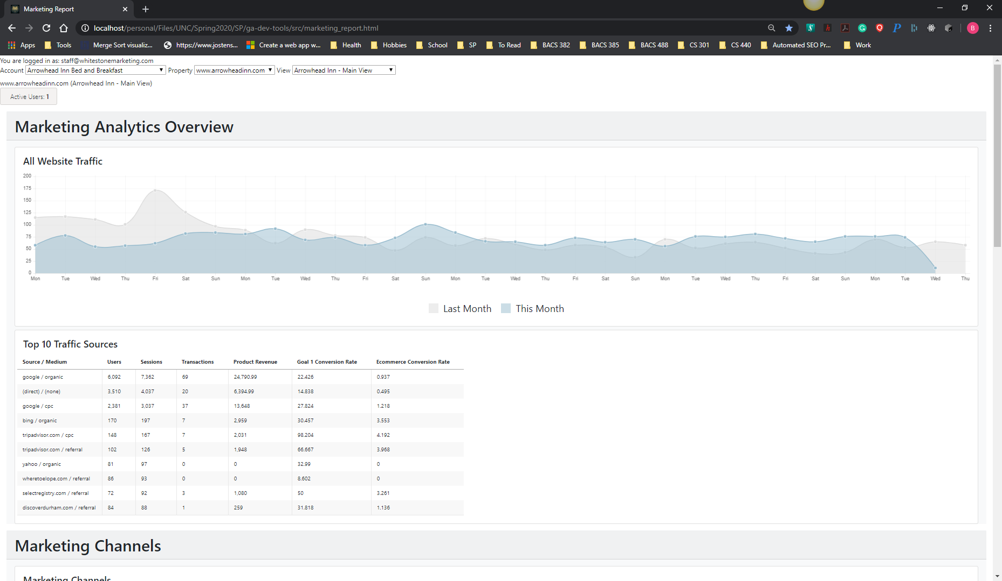

Figure 2. UC-2 Account Managers Page - filled

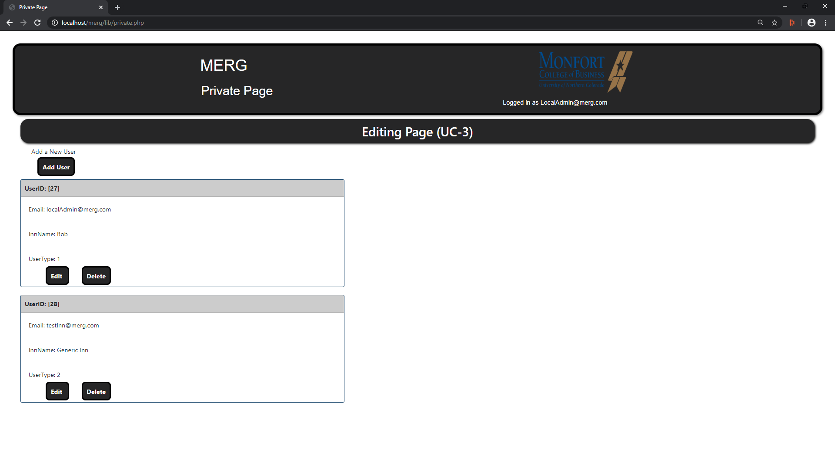

Figure 3. UC-3 Editing Page

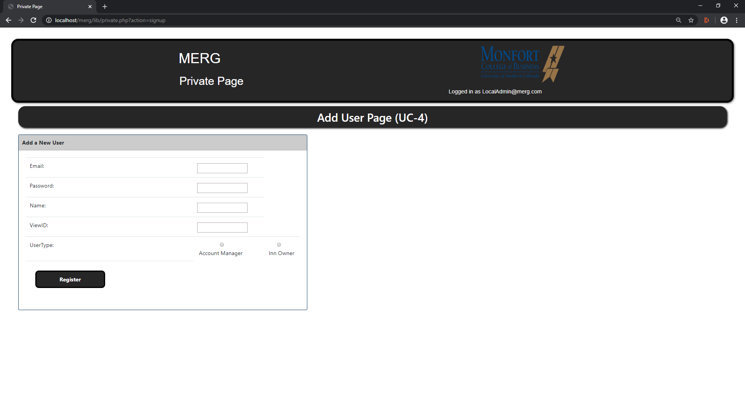

Figure 4. UC-4 Add User Page

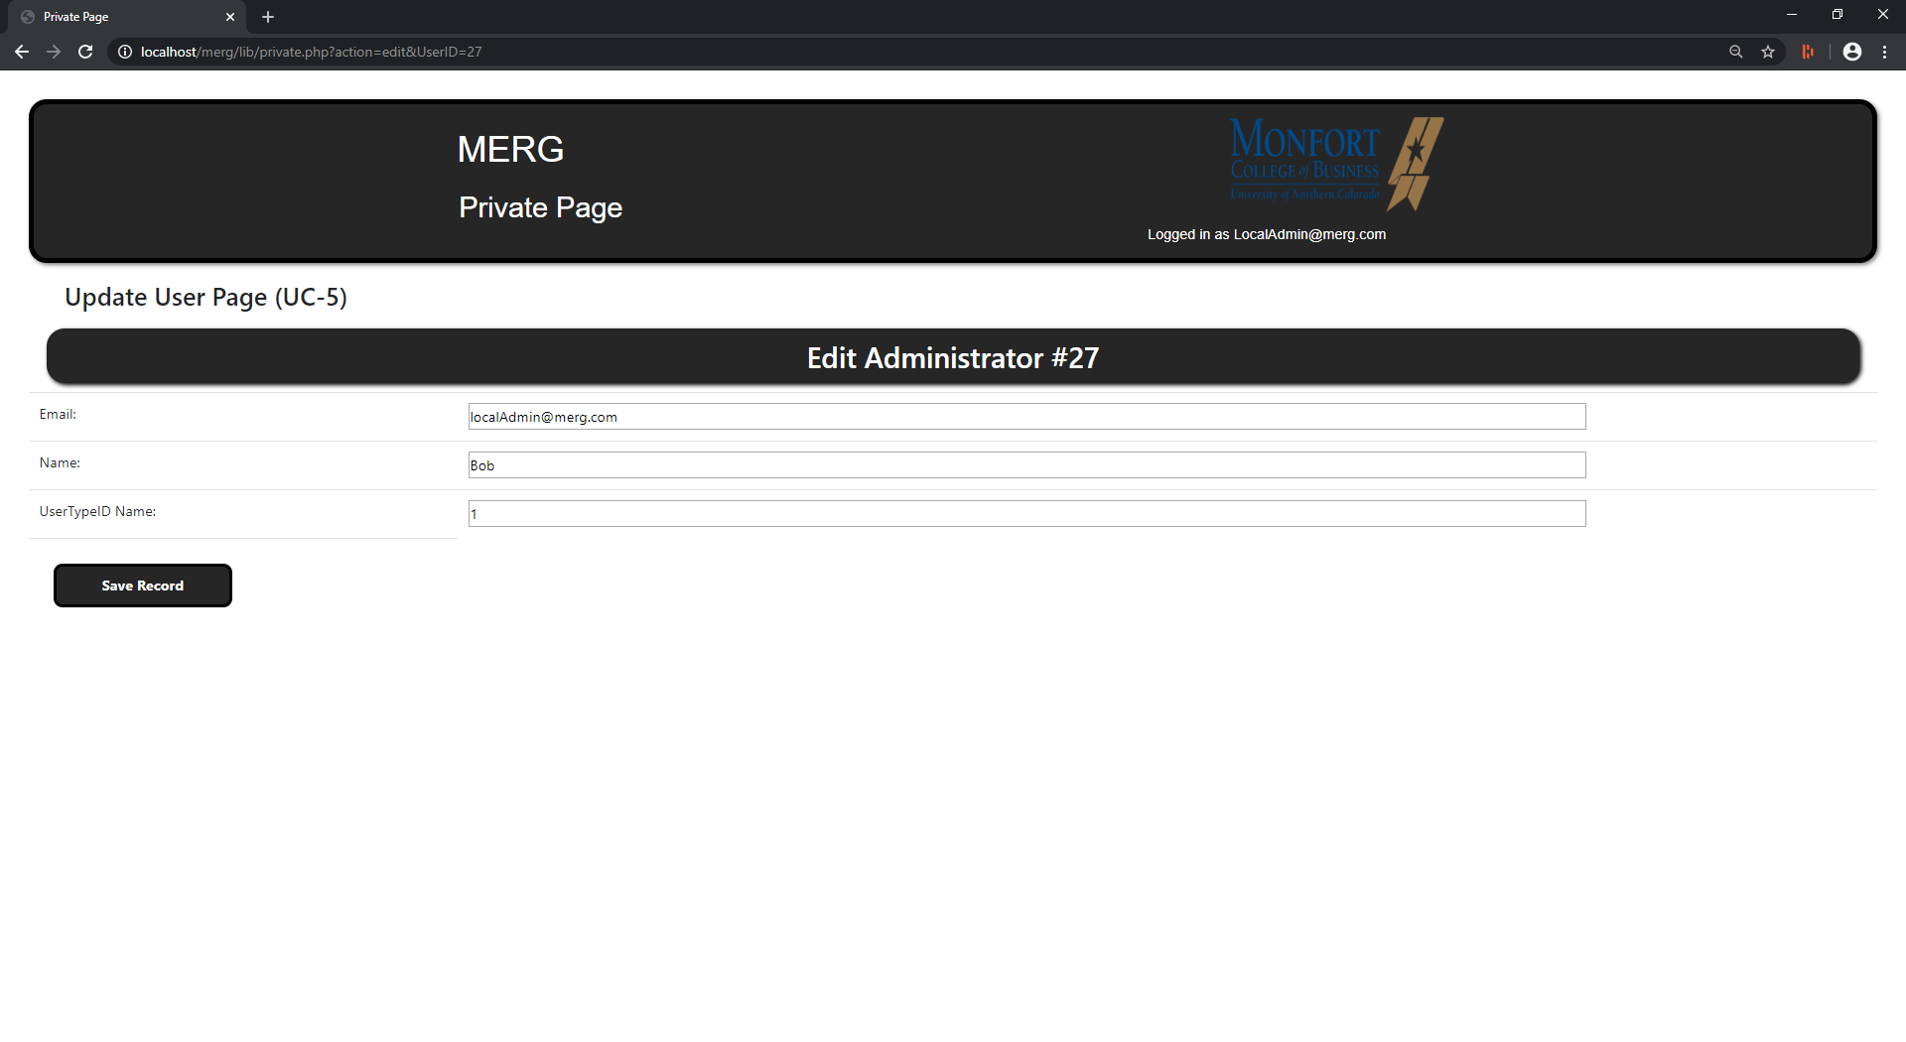

Figure 5. UC-5 Update User Page

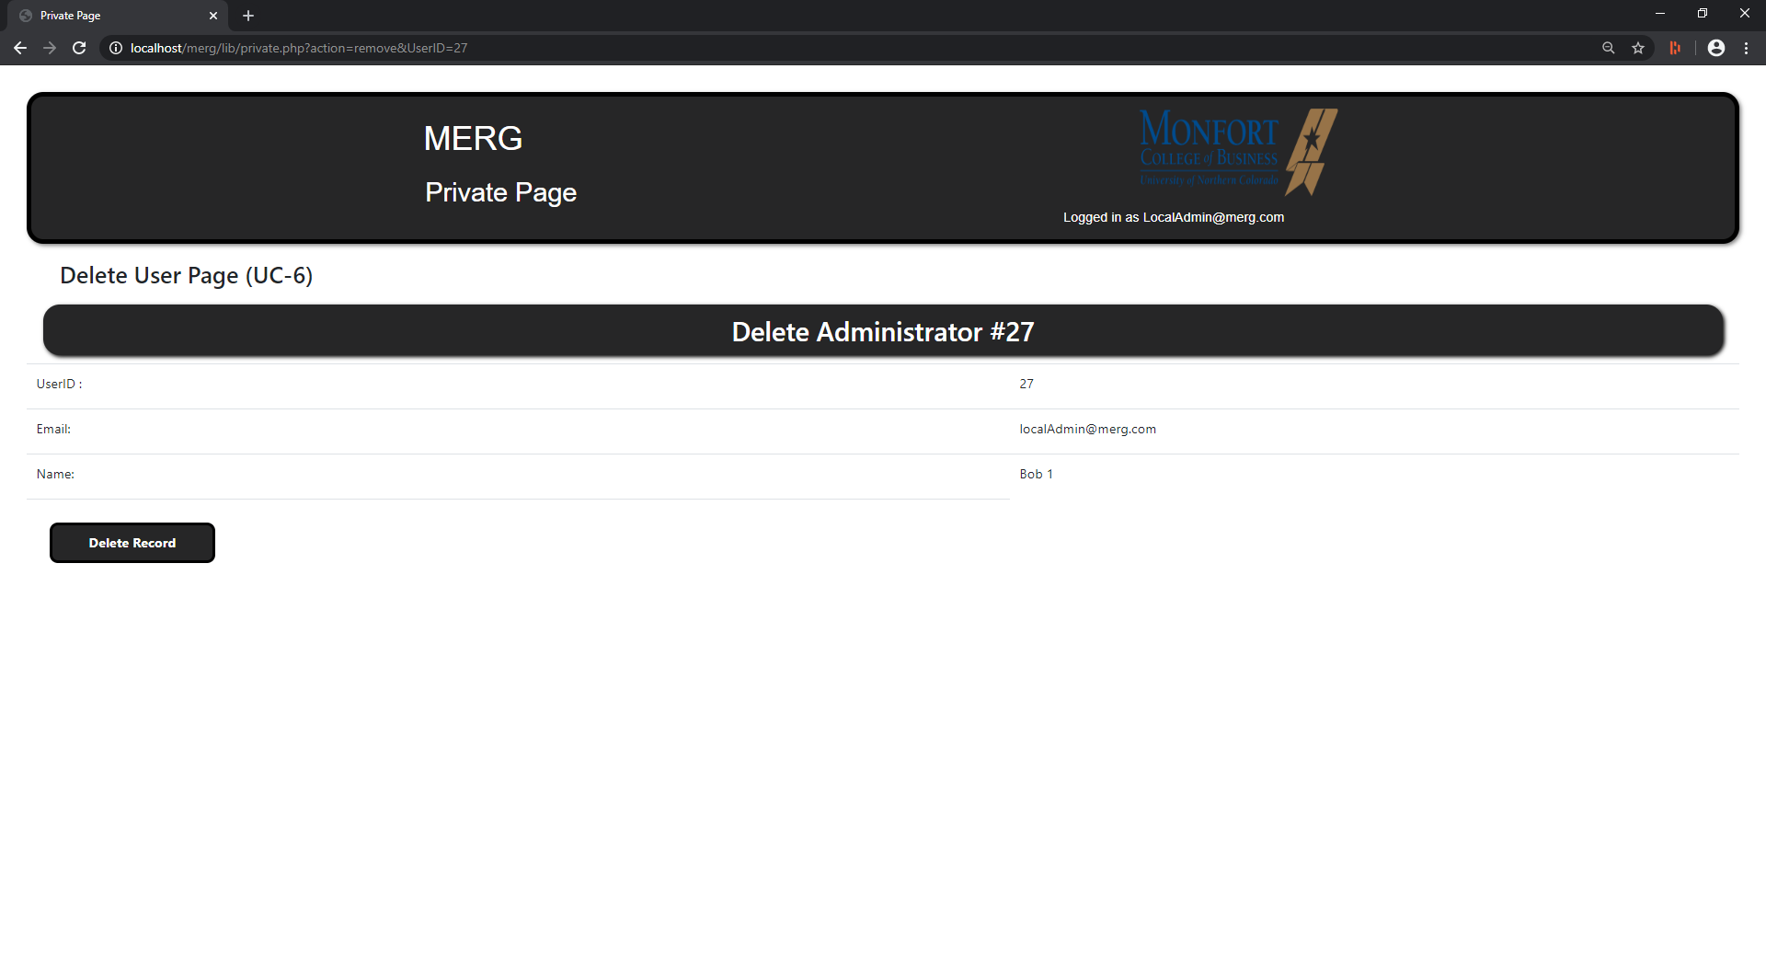

Figure 6. UC-6 Delete User Page

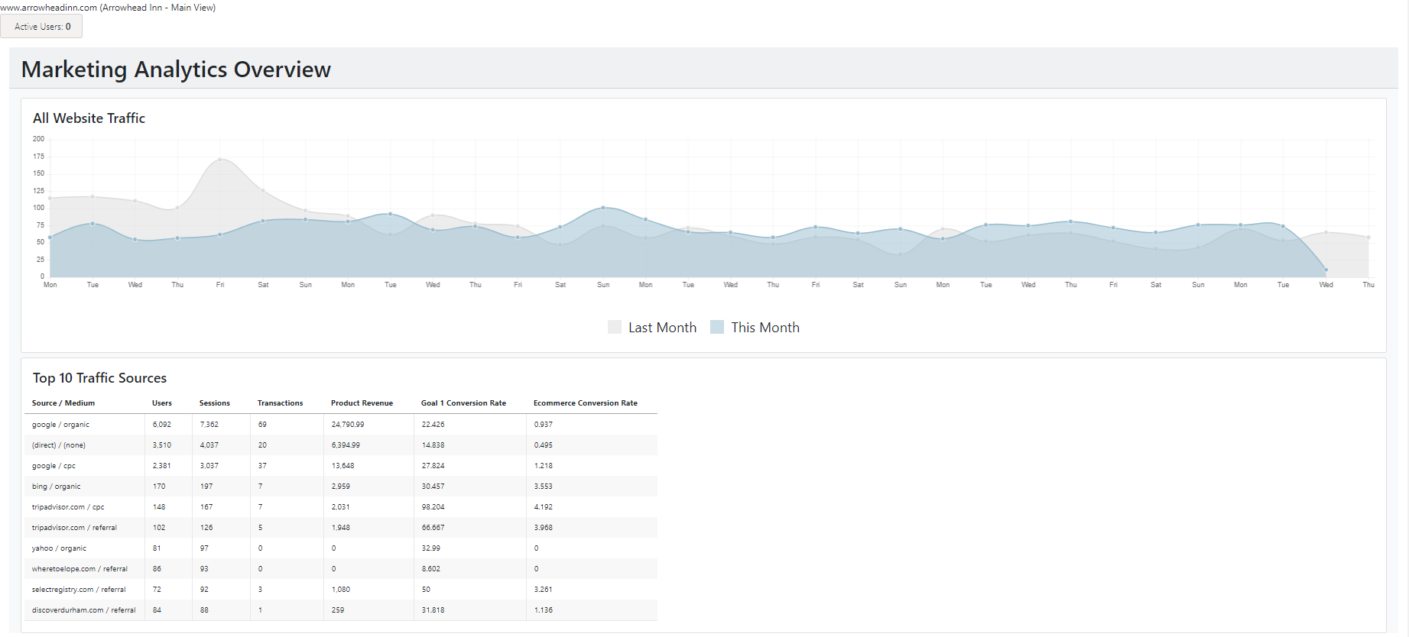

Figure 7. UC-7 Inn Owners Page – Marketing Analysis Overview

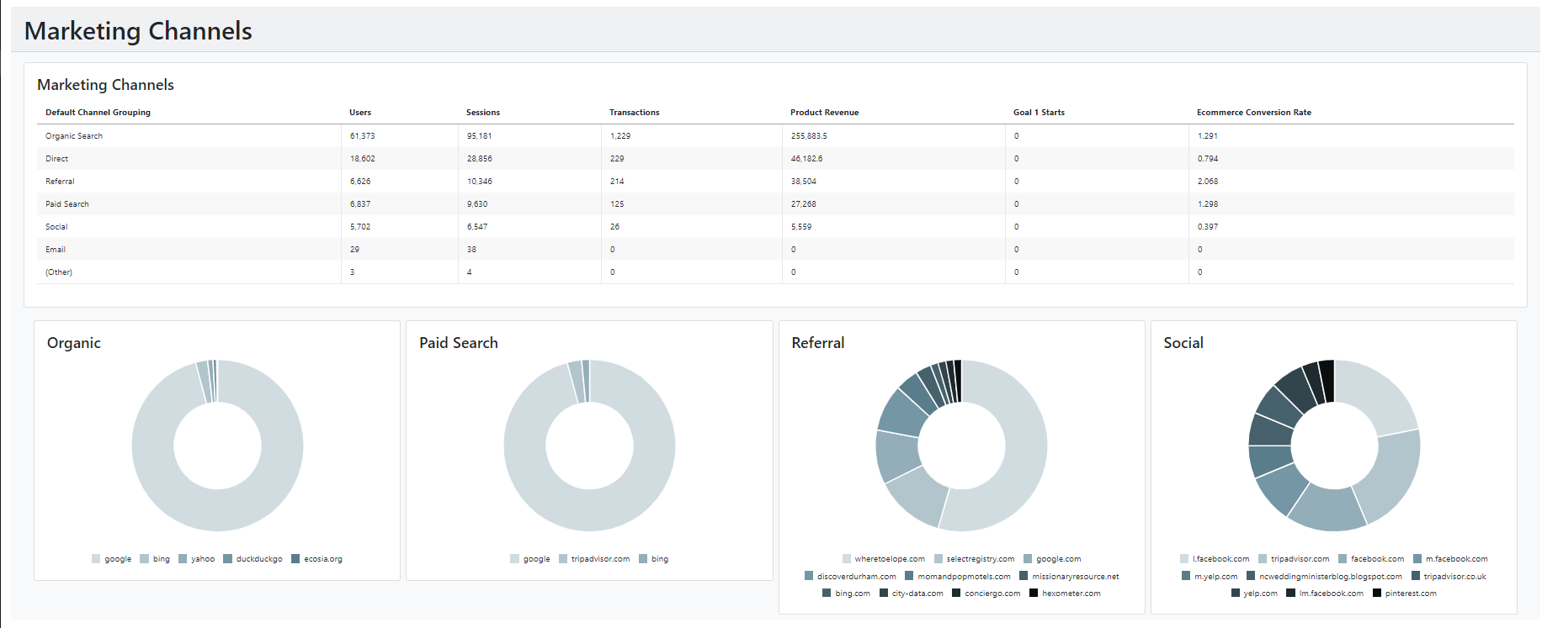

Figure 8. UC-7 Inn Owners Page cont – Marketing Channels

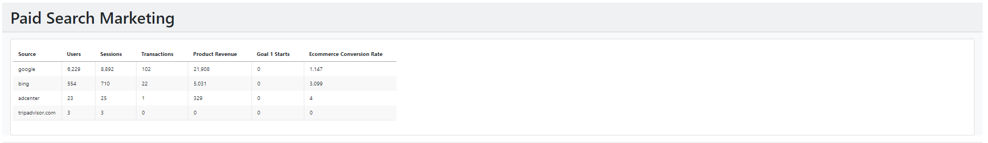

Figure 9. UC-7 Inn Owners page cont. – Paid Search Marketing

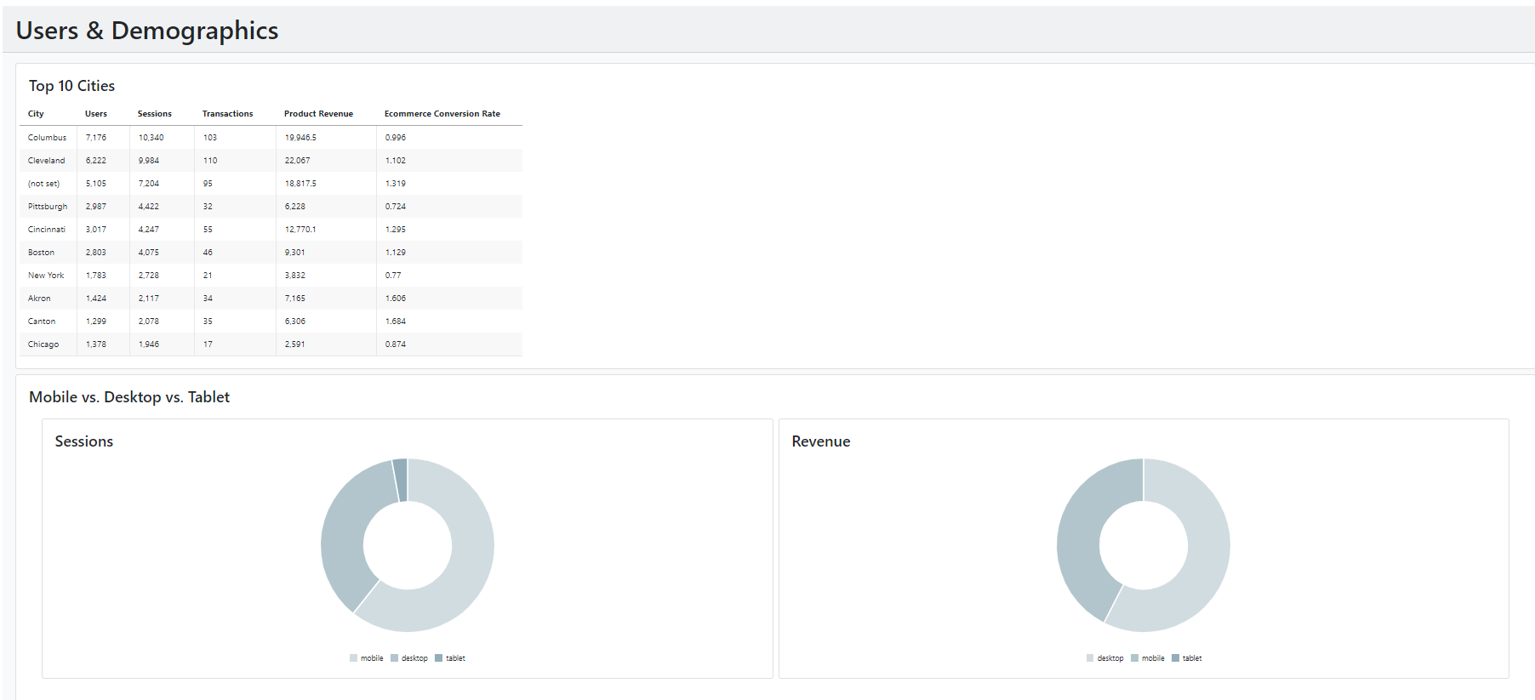

Figure 10. UC-7 Inn Owners Page cont – Users & Demographics

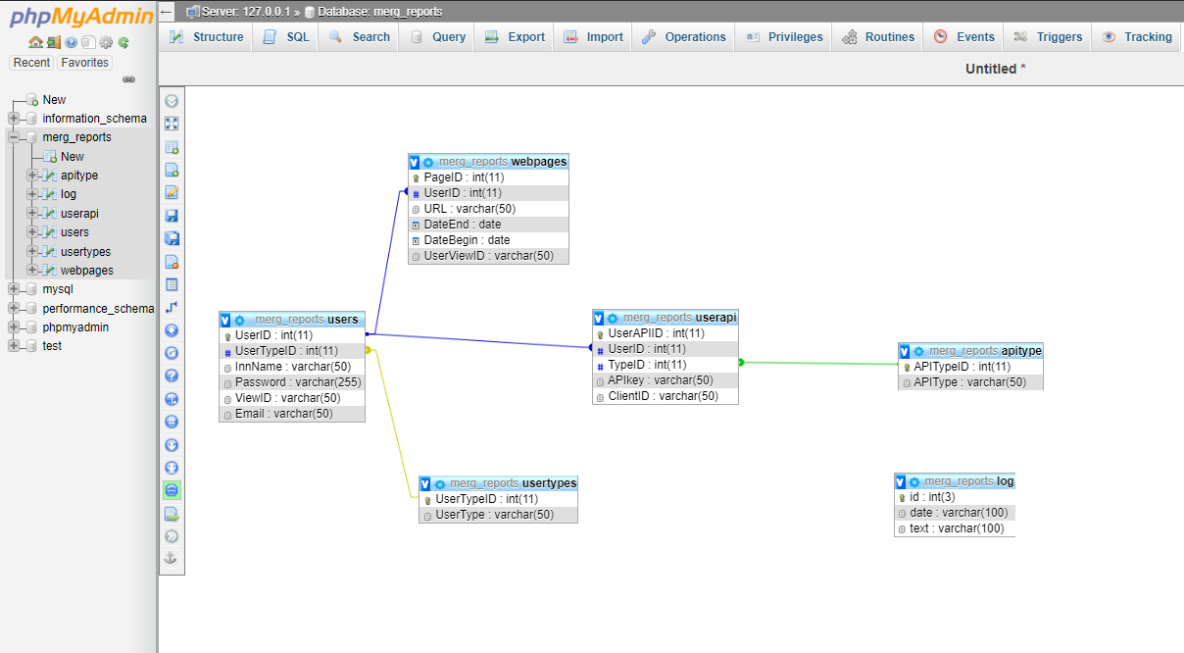

Figure 11. ERD of Database

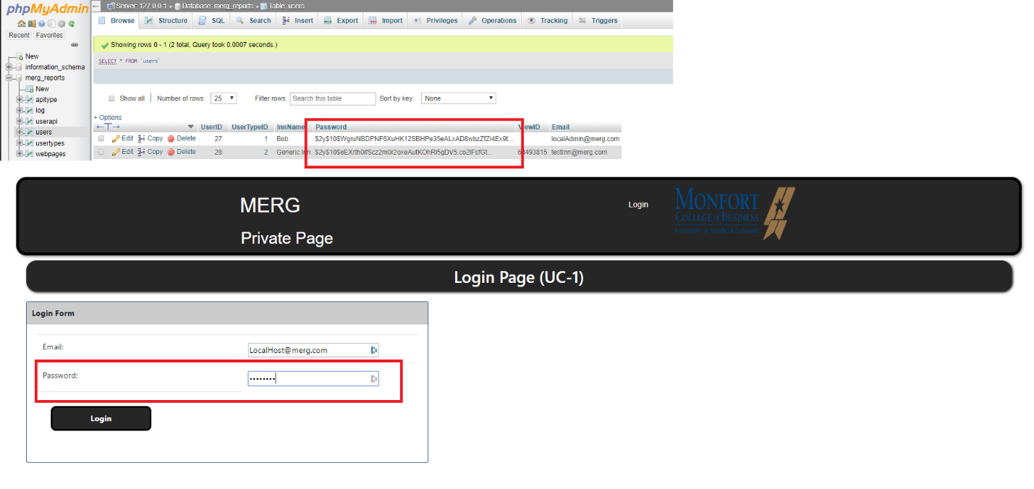

Figure 12. Shows password hashing and masking

**5. Issues, Unexpected Events and Lessons Learned**

In regards to user authentication, we had to overcome some unexpected events when we tried to query the database for the hashed password to be able to authenticate the user at the login screen. It was strange because everything else seemed to be working the way it was supposed to. We connected to the database with no issues and we were also able to create new users and hash their password, but when we tried login in it would fail. We looked at every line of code that had anything to do with authenticating a user. After looking for syntax errors or a misspelled call to a function we concluded that everything seemed to be in place. We began trying different approaches to hash a password along with other things, but we started to run out of places to look for errors. Since creating a user wasn't an issue we assumed the database was working properly but after looking carefully we were able to find the issue. When we went to register a user the built-in password hashing function in PHP was creating a hash that was longer than our max number of characters in the Password field. After increasing the number of characters allowed, we were able to hash the entire password and login to the website. Not that this was a major technical issue in our project but definitely a small hurdle that didn't make much sense at first. This reminded us to make sure that all the components for your application are compatible with each other.

Regarding our database, we were slightly concerned about the implementation of constraints and foreign keys in the beginning. However, this went fairly smoothly! There was a small hiccup regarding the foreign key implementation, but not as major as we thought might happen. We were able to implement the foreign keys after adding an index to each column from the database that was used in any type of relationship. Originally, our database tables were using the wrong database engine. Before we could even try to implement any relationship, we had to configure each table to run the “InnoDB” engine. Last, for the password hashing, we ran into a small hiccup as well, however, this was quickly fixed as Ben and Vicente were able to get that part done on the PHP side of the application.

Of course, with COVID-19 derailing our semester, we had to quickly come up with a plan of action for how we were going to continue working together and meeting each week to work on this. This did not change much for us however because our team did a great job making sure that we stayed in touch and met up on applications like Discord. I am very proud of the way the whole team handled the situation and nobody gave up or checked out after we all had our semester derailed.

**6. Future Work**

For this project to become fully operational a discussion needs to be had with the Client Whitestone Marketing. As part of the travel and hospitality industry, their clients have been greatly impacted my Covid-19, Whitestone has lost a large portion of their business, as such, they have pivoted to explore other means to provide service. If they wish to move forward then the topic of maintenance needs to be discussed as that would determine if Merg is hosted on their site or a third party site. As of now, the entire project would have to be refactored. If Whitestone wishes to host the service it would need to be integrated into their existing Wordpress based site. If hosted on a third party site then the project will be refactored in C# using Blazor pages and SQlite. Complete refactoring was anticipated as this project was simply a feasibility test, truly a throwaway system.

**7. Video Presentation**

See the merg-demo.mpg file included in the zip file for demonstration of functionality for marketing reports pages. All other functionality demonstrated in the linked video: [**https://www.youtube.com/watch?v=nWB7cZHeB2c&feature=youtu.be**](https://www.youtube.com/watch?v=nWB7cZHeB2c&feature=youtu.be)